“Email Behaviour Trends and Suspicious Content Insights Across Spam, Ham, and Phishing Messages”
ABSTRACT
Email spam has become a major problem in today’s digital communication, causing inconvenience, loss of time, unwanted information and security risks to the users. This project focuses on detecting spam emails. Email communication includes different types of messages ranging from normal conversations to unwanted promotional content and fraudulent attempts designed to mislead users. Spam emails often contain repetitive promotional language, ham emails represent regular communication, while phishing emails usually include suspicious content intended to create urgency or collect sensitive information. Understanding how these message types differ is important because their text patterns, word usage, and structure reflect different communication purposes and security implications. This project examines email content across spam, ham, and phishing categories to understand how message length, keyword frequency, and writing patterns vary between normal and suspicious emails. The analysis helps identify commonly repeated words, differences in text structure, and content characteristics associated with each category. It also provides insight into how phishing messages differ from spam through more targeted language and how ham messages maintain regular communication style. The study presents a clearer understanding of email behaviour and highlights important text patterns that distinguish suspicious digital messages from legitimate communication. The system helps in requiring minimal input while accurately filtering unwanted messages making it suitable for real-world email filtering analysis.

2. INTRODUCTION
In today’s digital environment, email communication has become an essential part of everyday life. It is widely used for personal interaction, business communication, educational purposes, and service notifications. Organizations depend on email systems for exchanging information, coordinating tasks, and maintaining records, while individuals use email for registrations, updates, and social communication. With the continuous increase in internet usage and digital services, the volume of emails exchanged daily has grown rapidly, making email one of the most important communication platforms in the modern world.
Along with the growth of email usage, there has also been a significant rise in unwanted and harmful messages. These messages are generally classified into categories such as spam and phishing emails. Spam emails mainly include promotional content, advertisements, or repetitive messages that are not relevant to the user. They often contain similar words and phrases repeated across multiple messages. On the other hand, phishing emails are more dangerous, as they are designed to mislead users by creating a sense of urgency or trust in order to collect sensitive information such as passwords, bank details, or personal data. These emails are carefully written to appear legitimate and can cause serious security threats.
The presence of such unwanted messages creates multiple problems. It leads to loss of time, reduced productivity, and difficulty in managing important emails. Users often need to manually sort through large numbers of messages to find relevant communication, which becomes inefficient as the volume increases. More importantly, phishing emails pose risks such as identity theft, financial loss, and data breaches. Therefore, identifying and understanding these different types of emails is an important task in maintaining secure and efficient communication systems.
Each category of email has its own characteristics in terms of structure, language, and content patterns. Spam emails usually contain promotional keywords, repeated phrases, and longer message formats. Phishing emails tend to use targeted language, urgent wording, and specific instructions to influence user actions. In contrast, normal emails follow a regular communication style with meaningful content and balanced structure. These differences can be observed by analyzing features such as message length, frequency of specific words, and overall writing patterns. Studying these characteristics helps in distinguishing between legitimate and suspicious emails.
This project focuses on analyzing email data to understand these patterns and differences across spam, ham, and phishing messages. The analysis involves examining textual content, identifying commonly used words, and observing how different types of messages vary in structure and intent. By working with structured datasets, the project performs data cleaning, organization, and analysis to extract useful insights. The processed data is further used to perform detailed analysis through query-based operations and visualization techniques, which help in identifying trends and patterns in email communication.
The role of technology in this context is to simplify the process of analyzing large volumes of email data and extracting meaningful information from it. Instead of manually reviewing each message, data analysis techniques allow for systematic examination of patterns, making it easier to identify unusual or suspicious behavior. This improves efficiency and helps in better understanding how different types of emails behave in real-world scenarios.
The outcomes of this project have practical applications in various areas. Email service providers can use such analysis to improve filtering systems and reduce unwanted messages in user inboxes. Organizations can monitor communication patterns to ensure secure information exchange. Additionally, understanding how phishing messages are structured can help in creating awareness among users about identifying suspicious emails. This contributes to improving digital safety and enhancing user experience in communication systems.
Overall, this project provides a detailed understanding of email behavior by analyzing content patterns across different categories of messages. It highlights how data analysis can be used to identify key differences between normal and suspicious emails, helping in improving communication efficiency and security.
3. EXISTING SYSTEM
The existing system in this domain is based on a simple Excel sheet used for storing and managing email-related data. The data is manually entered into the sheet, where each row represents a record and columns are used to store details such as message content and its category. The categories typically include different types of emails such as normal messages and unwanted messages.
The Excel sheet is primarily used for basic data storage. It allows users to view, organize, and maintain records in a structured tabular format. Each entry is stored in a straightforward manner, making it easy to read and access individual records when required.
The system also supports simple operations such as sorting and filtering data based on columns. This helps in viewing specific types of records, such as messages belonging to a particular category. The format remains simple and is mainly focused on maintaining a collection of records without involving complex processing.
Overall, the existing system serves as a basic method for recording and viewing email data in a structured format using an Excel sheet.
4. DISADVANTAGES OF EXISTING SYSTEM
The existing system, which is based on a simple Excel sheet with manually entered data, has several limitations when used for handling large and continuously growing email datasets. These disadvantages affect efficiency, accuracy, and overall usability in real-world scenarios.
- Time consuming data entry
The system relies on manual data entry, which requires significant time and effort. Each record must be entered individually, making the process slow, especially when dealing with large volumes of email data. This reduces productivity and delays data availability for analysis.
- High chances of human errors
Manual entry increases the risk of errors such as incorrect categorization, typing mistakes, or missing data. Even small mistakes can affect the quality of the dataset and lead to incorrect observations during analysis. Ensuring accuracy becomes difficult without proper validation mechanisms.
- Difficulty in handling large data
As the number of email records increases, the Excel sheet becomes harder to manage. Large datasets can slow down performance, making it difficult to load, edit, and navigate the file efficiently. This limits the system’s ability to handle real-world data volumes.
- Limited data organization
Although Excel provides a tabular structure, managing complex relationships between data fields is not easy. The system does not support advanced structuring, which makes it difficult to maintain well-organized and scalable data for detailed analysis.
- Inefficient data retrieval
Searching for specific records or patterns within a large Excel sheet can be time consuming. While basic filtering is available, it is not efficient for handling complex queries or extracting detailed insights from the data.
- Lack of automation
The system does not support automated data processing. Tasks such as categorizing messages, updating records, or preparing data for analysis must be done manually, increasing workload and reducing efficiency.
- No real time updates
The Excel based system does not support real time data updates. Any new data must be manually added, which makes it unsuitable for environments where data is continuously generated and needs to be updated frequently.
- Data inconsistency issues
Since multiple users may handle the file or data may be entered at different times, maintaining consistency becomes difficult. Variations in data entry formats and naming conventions can lead to inconsistent records.
- Limited collaboration
Working with Excel files in a shared environment can be challenging. Simultaneous access by multiple users may lead to version conflicts or accidental overwriting of data, affecting data integrity.
- Difficulty in maintaining data security
Basic Excel files do not provide strong security features for protecting sensitive data. Unauthorized access or accidental sharing of files can expose important information.
- Not suitable for advanced analysis
The system is mainly designed for storing and viewing data. Performing detailed analysis or identifying patterns within the data requires additional tools, as Excel alone is not sufficient for handling complex analytical tasks in large datasets.
- Poor scalability for real world applications
As data grows over time, the system becomes less efficient and harder to maintain. It is not designed to scale with increasing data requirements, making it unsuitable for long term use in real world applications involving large volumes of email data.
- 5. PROPOSED SYSTEM
- The proposed system is designed to provide an improved and structured approach for analyzing and understanding email data. Instead of relying on manual data handling, the system follows a step by step workflow that begins with data preparation and continues through structured storage, analysis, and visualization. The goal of this system is to handle email data more efficiently, reduce manual effort, and generate meaningful insights from the dataset.
- The system starts with collecting email data that contains message content and corresponding categories such as spam, ham, and phishing. This data is first processed in a controlled environment where it is cleaned and organized. Cleaning involves removing unnecessary characters, handling missing values, and ensuring that all records follow a consistent format. This step is important to maintain data quality before performing further operations.
- After cleaning, the data is structured into a well defined format and prepared for storage. The processed dataset is then stored in a database system where it can be accessed easily for further operations. Storing the data in this structured format helps in managing large volumes of records efficiently and supports better organization compared to simple file based storage.
- Once the data is stored, the system performs detailed analysis using query based operations. These queries help in extracting specific information such as identifying frequently used words, analyzing message lengths, and observing patterns across different categories. The analysis focuses on understanding how different types of emails vary in terms of content and structure. This step plays a major role in identifying trends and patterns within the dataset.
- In addition to query based analysis, the system also includes processing techniques that examine textual data more closely. The email messages are analyzed to understand how certain words and phrases appear across different categories. By studying these patterns, the system can differentiate between normal communication and suspicious messages. The outputs generated during this stage provide insights into how email content behaves in different scenarios. Some of these results and structured outputs are reflected in the project work .
- The system further includes visualization to represent the analyzed data in an understandable format. Graphs and charts are created to show variations in message patterns, category distribution, and keyword frequency. These visual representations make it easier to interpret the results and identify important trends without manually examining large datasets.
- The overall workflow of the proposed system can be described in a sequence of steps. It begins with data collection, followed by data cleaning and preprocessing. The cleaned data is then structured and stored for efficient access. After storage, analysis is performed using queries and processing techniques. Finally, the results are visualized to provide clear insights. Each step is connected and contributes to improving the overall data handling process.
- The logic of the system is based on transforming raw email data into meaningful information through systematic processing. Instead of directly working with unstructured data, the system organizes it into a structured form, applies analysis techniques, and generates outputs that highlight differences between various types of messages. This logical flow ensures that the data is processed in an efficient and consistent manner.
- The technologies used in the proposed system support each stage of the workflow. Data handling and preprocessing are performed using structured programming techniques. The organized data is stored in a database system to allow efficient querying and management. Analytical operations are carried out using query based methods to extract useful insights. Visualization tools are used to present the results in a clear and understandable manner. Each technology plays a specific role in improving the overall system performance.
- Compared to the existing system, the proposed system introduces several improvements. It reduces manual effort by automating data processing steps. It improves accuracy by minimizing human errors during data handling. It supports better data organization through structured storage. It also allows efficient retrieval of information using queries, which makes analysis faster and more reliable.
- The proposed system is also capable of handling larger datasets more effectively. As the volume of email data increases, the system maintains its performance by using structured storage and efficient processing methods. This makes it more suitable for real world applications where data is continuously growing.
- Another important improvement is the ability to generate meaningful insights from the data. Instead of just storing and viewing records, the system actively analyzes patterns and provides outputs that help in understanding email behavior. This adds value to the data and supports better decision making.
- Overall, the proposed system provides a complete solution for handling email data, starting from raw data collection to final analysis and visualization. It improves efficiency, accuracy, and scalability while offering a structured approach to understanding different types of email messages.
6. ADVANTAGES OF PROPOSED SYSTEM
The proposed system offers several improvements over traditional methods by providing a structured and efficient way of handling email data. It focuses on improving accuracy, reducing manual effort, and enabling better analysis of large datasets. The advantages of this system are explained below in detail.
- Improved accuracy
The system ensures better accuracy by processing data in a structured and consistent manner. Since the data is cleaned and organized before analysis, the chances of incorrect or inconsistent records are reduced. This leads to more reliable results when identifying patterns in different types of email messages. Proper handling of text data also helps in maintaining uniformity across all records.
- Higher efficiency in data handling
The proposed system significantly improves efficiency by reducing the time required to manage and analyze data. Instead of manually handling records, the system processes large volumes of data in a systematic way. Tasks such as organizing, filtering, and analyzing email content are performed faster, allowing users to obtain results quickly. This makes the system suitable for handling increasing data volumes.
- Automation of processes
One of the major advantages is the automation of multiple steps in the workflow. Data cleaning, structuring, and analysis are performed through predefined processes, reducing the need for manual intervention. This not only saves time but also ensures consistency in operations. Automated handling of repetitive tasks improves overall productivity and reduces dependency on manual work.
- Better data organization
The system organizes data in a structured format, making it easier to store, access, and manage. Well organized data helps in maintaining clarity and avoids confusion when dealing with large datasets. It also supports efficient retrieval of information when required, which is important for analysis and reporting purposes.
- Scalability for large datasets
The proposed system is capable of handling large and continuously growing datasets. As the volume of email data increases, the system maintains its performance without major issues. This makes it suitable for real world applications where data is generated regularly and needs to be processed efficiently.
- Faster data retrieval and analysis
The system allows quick retrieval of specific data using structured operations. Instead of manually searching through records, users can extract required information in a short time. This improves the speed of analysis and helps in identifying patterns and trends more effectively.
- Consistency in results
Since the system follows a defined workflow, the results produced are consistent across different runs. The same input data will generate similar outputs when processed under the same conditions. This consistency is important for maintaining reliability in analysis.
- Reduction in manual workload
By automating key processes, the system reduces the need for manual effort. Users do not have to spend time on repetitive tasks such as sorting, filtering, or organizing data. This allows them to focus more on interpreting results and making decisions based on the analysis.
- Better understanding of data patterns
The system helps in identifying meaningful patterns in email data by analyzing text content, frequency of words, and message structure. This improves the understanding of how different types of emails behave and how they can be differentiated based on their characteristics.
- Real world applicability
The proposed system can be applied in practical scenarios such as managing large volumes of email communication, improving filtering processes, and analyzing communication patterns. It helps organizations and users handle email data more effectively and supports better decision making.
- Enhanced productivity
With faster processing, reduced errors, and automated workflows, the system improves overall productivity. Tasks that previously required significant time and effort can now be completed more efficiently, leading to better utilization of resources.
- Flexible and adaptable system
The system can be adapted to different types of datasets and requirements. It is not limited to a fixed structure and can be extended based on future needs. This flexibility makes it useful for a variety of data analysis tasks beyond the current scope.
Overall, the proposed system provides a comprehensive solution that improves accuracy, efficiency, and scalability while offering practical benefits for real world data handling and analysis.
7. INTRODUCTION TO APPLICATION
The application developed in this project is designed to handle, process, and analyze email message data in a structured and organized manner. It works with datasets that contain different categories of emails such as spam, ham, and phishing, and focuses on examining their content to understand patterns and differences. The system transforms raw data into meaningful insights through a sequence of processing steps, making it easier to study email behavior and identify important characteristics within the data.
The application performs multiple functions starting from data input to final output generation. It accepts structured data containing email messages and their respective categories. Once the data is provided, the system processes it by cleaning and organizing the content to ensure consistency. After this step, the data is prepared for further analysis where patterns such as word usage, message length, and category distribution are examined. The application then generates outputs in the form of structured results and visual representations, which help in understanding the data clearly.
One of the key features of the application is its ability to manage and process large volumes of email data efficiently. Instead of manually handling records, the system performs operations in a systematic manner. It ensures that the data remains organized throughout the workflow, which helps in maintaining clarity and reducing confusion. Another important feature is its ability to analyze textual content, where the application studies how different words and phrases appear across various categories of emails. This helps in identifying differences between normal and suspicious messages.
The application also includes features that support easy data viewing and interpretation. It presents the processed data in a structured format, making it simple to understand the results. Visualization features are used to represent patterns and trends in the data, allowing users to quickly observe differences between categories without going through raw data manually. These features improve the overall usability of the system.
User interaction with the application is simple and straightforward. The user provides the dataset in a predefined format, and the system performs all the necessary processing steps internally. The user does not need to perform complex operations, as the application handles data cleaning, organization, and analysis automatically. After processing, the user can view the results, explore patterns, and interpret the findings through the outputs generated by the system.
The flow of data within the application follows a clear sequence. Initially, data is collected and provided as input to the system. This data then goes through a cleaning and preprocessing stage where unnecessary elements are removed and consistency is maintained. After preprocessing, the data is structured and stored in an organized format. The system then performs analysis to extract meaningful information from the data. Finally, the processed results are displayed through tables and visual formats, making it easier for users to understand the outcomes.
The application ensures that each stage of the process is connected, creating a smooth and continuous workflow from input to output. By following this structured flow, the system is able to handle data efficiently and produce reliable results. It provides a practical solution for analyzing email data and understanding the differences between various types of messages in a clear and organized way.
8. Explanation of Block Diagram
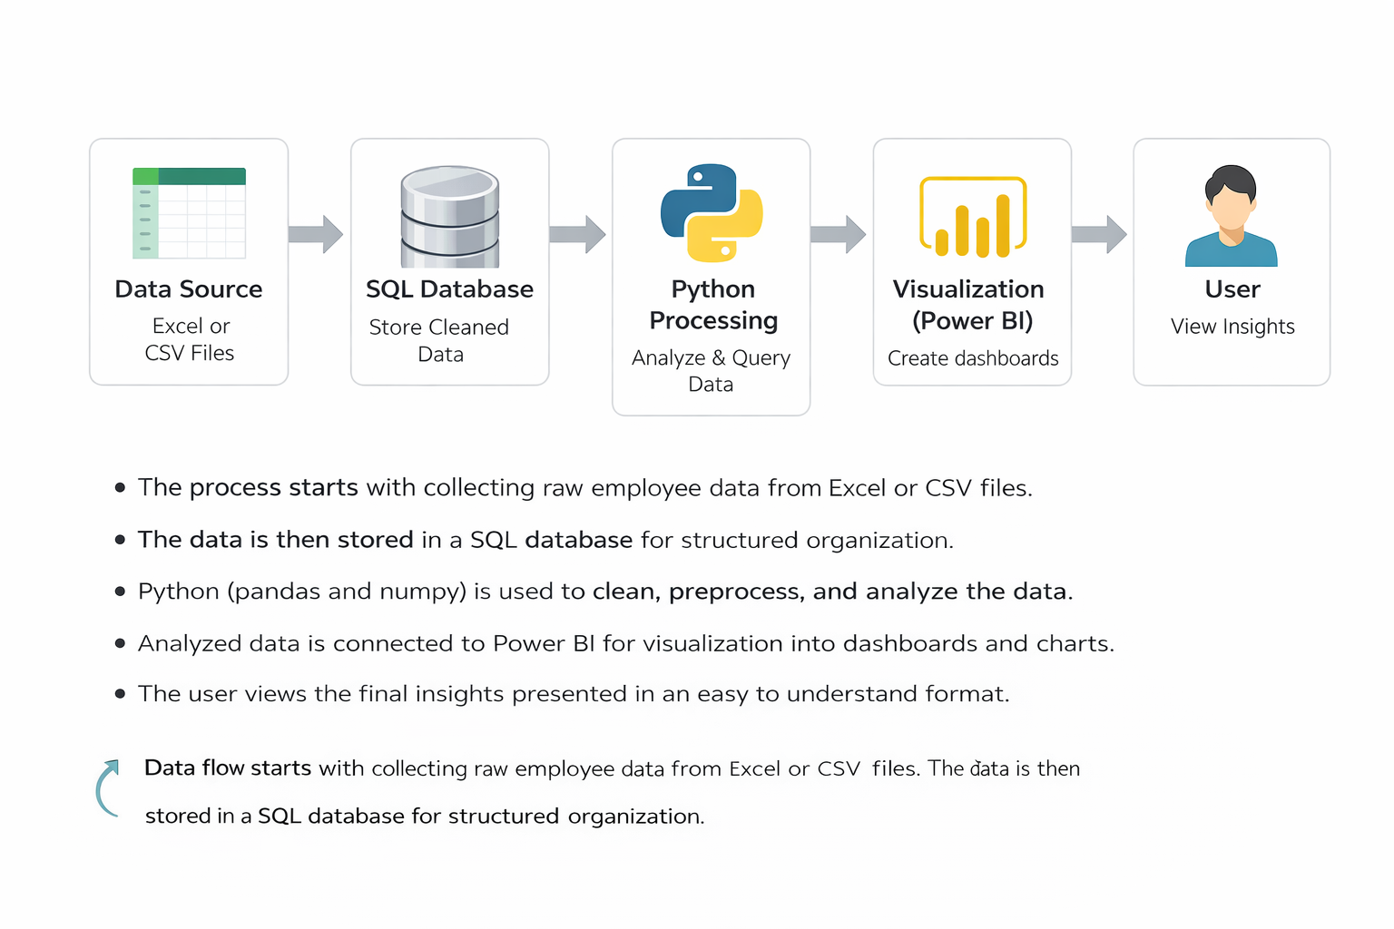
Data Source
This is the starting point of the system. It contains the raw email data collected in the form of Excel or CSV files. The data includes message content and categories such as spam, ham, and phishing. This block handles unprocessed and initial data.
SQL Database
In this stage, the cleaned and structured data is stored in a database. It helps in organizing the data in a proper format so that it can be easily accessed and managed. The database stores records in tables, making it easier to perform operations on large datasets.
Python Processing
This block is responsible for processing the stored data. It includes data cleaning, organizing, and analysis. Operations such as checking message length, identifying repeated words, and preparing data for further analysis are performed here. This stage transforms raw data into meaningful information.
Visualization (Power BI)
In this stage, the processed data is converted into visual formats such as charts, graphs, and cards. These visuals help in understanding patterns and trends in the data. It makes the results easy to interpret without going through raw tables.
User
The final output is presented to the user. The user interacts with the visual reports to understand insights from the data. The user can view patterns, compare categories, and analyze results easily through the dashboard.
Data Flow Explanation
The process begins with collecting email data from the data source. This raw data is then cleaned and prepared before being stored in the database. Once stored, the data is processed to extract useful information and patterns. The processed data is then sent to the visualization stage where it is presented in graphical form. Finally, the user views and interprets the results through the dashboard.

9. DATA ANALYTICS SECTION
9.1 Overview
Data analytics is the process of examining, organizing, and interpreting data in order to extract meaningful information and useful insights. It involves working with structured data to identify patterns, trends, and relationships that help in understanding the behavior of the data. In this project, data analytics plays a central role in studying email messages and identifying how different types of emails vary in terms of content, structure, and usage of words.
The importance of data analytics in this project lies in its ability to convert raw email data into understandable information. Email datasets contain large amounts of textual data, which cannot be easily interpreted without proper analysis. By applying data analytics techniques, the system is able to process this data, organize it, and highlight important patterns such as frequently used words, differences in message length, and variations between spam, ham, and phishing messages. This helps in gaining a clear understanding of how different categories of emails behave.
Data analytics also improves decision making by providing structured insights instead of raw information. Instead of manually reading each email, the analysis summarizes key characteristics of the dataset, making it easier to identify unusual or suspicious patterns. This reduces effort and allows users to focus on interpreting results rather than handling data manually.
There are different types of data analytics used in this project, each serving a specific purpose in the analysis process.
Descriptive analytics is used to summarize and present the basic features of the data. It helps in understanding what the data contains by providing information such as total number of messages, distribution of categories, and common patterns in text. This type of analysis gives an overall view of the dataset and forms the foundation for further analysis.
Diagnostic analytics focuses on identifying reasons behind certain patterns observed in the data. For example, it helps in understanding why certain words appear more frequently in spam messages or why phishing emails use specific types of language. This type of analysis looks deeper into the data to explain observed behavior.
Predictive analytics is used to identify possible outcomes based on existing data patterns. By studying the characteristics of different email categories, the system can estimate how new or unseen messages might behave. This helps in understanding potential trends and supports better handling of incoming data.
Prescriptive analytics focuses on suggesting actions based on the analysis results. It provides guidance on how the identified patterns can be used in practical scenarios, such as improving filtering processes or organizing email data more effectively.
In this project, these types of analytics work together to provide a complete understanding of email data. Descriptive analytics provides an overview, diagnostic analytics explains patterns, predictive analytics identifies possible outcomes, and prescriptive analytics suggests improvements. Together, they help in transforming raw email data into valuable insights that support better analysis and understanding.
9.2 Data Description
The dataset used in this project consists of structured email message data collected for the purpose of analyzing different types of communication. Each record in the dataset represents a single email message, and the data is organized in a tabular format where rows correspond to individual emails and columns represent specific attributes related to those emails. The dataset includes both textual and categorical data, which allows detailed analysis of message content and classification.
The primary column in the dataset is the message content column. This column contains the actual text of the email message. It is a text type field and forms the core of the dataset, as all analysis is performed based on the content of these messages. The text includes different styles of writing such as normal communication, promotional content, and suspicious messages. This column is essential for identifying patterns such as commonly used words, message length, and writing style differences across categories.
Another important column in the dataset is the category or label column. This column indicates the type of email message and is usually stored as categorical data. The categories include spam, ham, and phishing. This column helps in classifying the messages and plays a key role in comparing how different types of emails vary in terms of content and structure. It also allows grouping of data for analysis and visualization.
In addition to these main columns, the dataset may include derived or processed columns that are created during data handling. For example, a message length column can be included to store the number of characters or words in each email. This is a numerical field and helps in analyzing how message size differs between categories. Similarly, word count or keyword frequency columns may be generated to track how often certain words appear in different messages. These columns support deeper analysis and help in identifying meaningful patterns.
The dataset can also include cleaned text columns where unnecessary characters such as punctuation, extra spaces, or special symbols are removed. This ensures that the data remains consistent and suitable for analysis. Cleaned data improves accuracy and makes it easier to compare different messages without inconsistencies.
The relevance of this dataset lies in its ability to represent real world email communication. It captures different types of messages with varying intentions and structures. By analyzing this data, it becomes possible to understand how spam messages differ from normal communication and how phishing emails use specific language patterns. The dataset provides a foundation for identifying key characteristics that distinguish one category from another.
Overall, the dataset is well structured and contains a combination of text and categorical information. It supports detailed analysis of email content and enables the identification of patterns, trends, and differences across various types of messages. This makes it suitable for understanding email behavior and performing meaningful data analysis within the scope of the project.

9.3 Data Preprocessing
Data preprocessing is an important step in the project, where raw email data is prepared for analysis. The dataset initially contains unstructured and inconsistent information, which needs to be cleaned and organized before meaningful insights can be extracted. This stage ensures that the data is accurate, consistent, and suitable for further processing.
Cleaning
Data cleaning involves removing unnecessary and unwanted elements from the dataset. Email messages often contain extra spaces, punctuation marks, special characters, and irrelevant text that do not contribute to analysis. These elements are removed to make the data uniform and easier to process. Cleaning also includes converting text into a consistent format, such as using the same letter case throughout the dataset. This step improves clarity and ensures that similar words are treated equally during analysis.
Handling missing values
In some cases, the dataset may contain missing or incomplete records. These missing values can affect the quality of analysis if not handled properly. The preprocessing step identifies such records and handles them appropriately. Depending on the situation, missing values may be removed or replaced with suitable alternatives. This ensures that the dataset remains complete and does not lead to incorrect results during analysis.
Formatting
Formatting is done to maintain consistency in how data is stored and represented. This includes organizing columns properly, ensuring correct data types for each field, and standardizing the structure of the dataset. For example, text fields are maintained in a uniform format, while numerical values such as message length are stored in appropriate numeric formats. Proper formatting makes the data easier to work with and helps in smooth execution of further analysis steps.
Feature engineering
Feature engineering involves creating new columns or attributes from the existing data to improve analysis. In this project, additional features such as message length, word count, and frequency of specific keywords are generated from the original message content. These new features help in understanding patterns more clearly and provide deeper insights into the dataset. For example, analyzing message length can show differences between normal and suspicious emails, while keyword frequency can highlight commonly used terms in different categories.
Overall, data preprocessing transforms raw and unorganized email data into a clean, structured, and enriched dataset. This step is essential for ensuring accurate analysis and helps in extracting meaningful patterns from the data.
9.4 Exploratory Data Analysis (EDA)
Exploratory Data Analysis is performed to understand the underlying patterns, trends, and structure of the email dataset. This stage focuses on examining the data in detail before drawing conclusions. It helps in identifying how different types of email messages behave and how their characteristics vary across categories such as spam, ham, and phishing.
One of the primary observations in the dataset is the distribution of email categories. By analyzing the number of messages in each category, it becomes possible to understand how the data is balanced. In many cases, spam messages tend to appear more frequently compared to other categories, while ham messages represent regular communication. Phishing messages may appear in smaller numbers but show distinct patterns in their content. This distribution provides an overall view of how the dataset is structured.
Another important aspect of analysis is the examination of message length. Different categories of emails show variation in the length of messages. Spam emails often contain longer content with repeated promotional text, while ham emails usually have moderate and meaningful content. Phishing emails may vary in length but often include specific instructions or urgent statements. By analyzing message length, clear differences can be observed between normal and suspicious emails.
Word frequency analysis is also a key part of exploratory analysis. By identifying commonly used words in each category, patterns in language usage can be observed. Spam emails frequently include promotional words, offers, or repeated phrases. Phishing emails tend to use words related to urgency, verification, or sensitive actions. In contrast, ham emails use regular conversational language. These differences in word usage help in understanding how each category communicates its intent.
The structure and writing style of messages also show noticeable trends. Spam messages often follow a repetitive and generic format, while phishing messages are more targeted and may mimic official communication. Ham messages usually have a natural and consistent writing style. Observing these structural patterns provides deeper insight into how different types of emails are composed.
The analysis also reveals relationships between different attributes in the dataset. For example, message length and word frequency together can indicate the nature of the email. Longer messages with repeated keywords are often associated with spam, while shorter and structured messages may belong to normal communication. Identifying such relationships helps in understanding how different features interact with each other.
Visualization of data further supports exploratory analysis by presenting patterns in a clear and understandable way. Graphs and charts are used to represent category distribution, variations in message length, and frequency of commonly used words. These visual representations make it easier to identify trends and compare different categories without manually examining the dataset.
Overall, exploratory data analysis provides a detailed understanding of the dataset by highlighting key patterns and trends. It helps in identifying differences between email categories based on content, structure, and frequency of words. This stage forms the foundation for further analysis by ensuring that the data is well understood before drawing insights.
9.5 TOOLS USED
The following tools are used in this project to perform data processing, analysis, storage, and visualization. Each tool plays a specific role in the overall workflow.
1. Python
Python is the core programming tool used for implementing the entire data analysis process. It is used to write scripts for data cleaning, transformation, and analysis.

2. Jupyter Notebook
Jupyter Notebook is used as the development tool where Python code is written and executed. It provides an interactive environment to run code step-by-step and view outputs instantly.

3. Pandas
Pandas is used for data manipulation and handling structured data. It helps in reading datasets, filtering data, grouping values, and creating new columns required for analysis.

4. NumPy
NumPy is used for numerical computations. It supports mathematical operations and helps in handling arrays and performing calculations efficiently.

5. Matplotlib
Matplotlib is used for creating visualizations such as bar charts and histograms. It helps in understanding patterns and trends in the dataset during analysis.

6. MySQL
MySQL is used as the database tool for storing and managing the dataset. It allows execution of SQL queries to retrieve and analyze data efficiently.

7. Microsoft Power BI
Power BI is used as the visualization and reporting tool. It is used to create interactive dashboards, charts, and KPI indicators for better understanding of insights.

Summary
These tools work together to form a complete data analytics pipeline. Python and its libraries handle data processing, MySQL manages data storage, and Power BI provides visualization, making the system efficient and easy to use.

10. SOFTWARE REQUIREMENTS
Software requirements refer to the platforms and environments needed to develop, run, and execute the project. These provide the base setup where all tools and libraries function.
1. Operating System
The project can run on operating systems such as Windows, macOS, or Linux. In this project, a Windows environment is typically used, which supports Python, Jupyter Notebook, and other required tools. The operating system manages file handling, software installation, and execution of programs.

2. Python Environment
Python is required as the core programming language. A proper Python environment must be installed to execute scripts and run data analysis.
In this project:
- Python is used to write all preprocessing and analysis logic
- It acts as the base for libraries like pandas, NumPy, and matplotlib
- Version compatibility is important to ensure smooth execution

3. Jupyter Notebook Environment
Jupyter Notebook is required as the development platform for writing and running code interactively.
In this project:
- It provides an interface to execute Python code step-by-step
- It allows combining code, outputs, and explanations in one place
- It helps in testing and debugging during development

4. Library Support (Python Packages)
The system requires installation of essential Python libraries. These are not standalone software but part of the Python environment.
Required libraries include:
- pandas for data handling
- NumPy for numerical operations
- matplotlib for visualization
These libraries must be installed using package managers such as pip before running the project.

5. Database Software (MySQL)
MySQL is used as the database system for storing and querying structured data.
In this project:
- It stores insurance dataset in table format
- SQL queries are executed to filter and analyze data
- It supports structured data management and retrieval

6. Data Visualization Software (Microsoft Power BI)
Power BI is required for creating dashboards and visual reports.
In this project:
- It connects to processed data
- It is used to build interactive dashboards
- It helps in visualizing insights using charts and KPI cards

7. Web Browser
A web browser such as Chrome or Edge is required to access Jupyter Notebook and Power BI interfaces. It provides the interface for interacting with dashboards and notebooks.

Summary
The software requirements define the environment needed to run the project successfully. Python and Jupyter Notebook provide the development platform, MySQL manages data storage, and Power BI handles visualization. Together, these components create a complete system setup for executing the insurance data analytics project.
11. HARDWARE REQUIREMENTS
1. Processor
- Minimum Intel Core i3 or equivalent
- Recommended Intel Core i5 or higher
The processor is responsible for executing all operations in the system. A basic processor like i3 can handle small datasets and simple analysis. However, for better performance, especially when running multiple tools such as Jupyter Notebook and Power BI together, a higher processor like i5 or above is preferred. A faster processor reduces computation time and improves overall system responsiveness.
2. RAM
- Minimum 4 GB RAM
- Recommended 8 GB or more
RAM is used to temporarily store data during execution. A minimum of 4 GB is sufficient for basic tasks, but it may cause slow performance when handling larger datasets. Using 8 GB or more allows smoother multitasking and faster data processing. Higher RAM ensures that the system does not lag when multiple applications are running.
3. Storage
- Minimum 256 GB storage
- Recommended SSD storage
Storage is required to install software and store datasets and project files. A minimum of 256 GB is needed for proper functioning. Solid State Drives are recommended over traditional hard drives because they provide faster data access and improve system speed. Faster storage reduces loading time and enhances performance.
4. Operating System
- Windows, macOS, or Linux supported
- Recommended 64-bit Windows 10 or above
The operating system acts as the base platform for running all tools and applications. A 64-bit system is recommended for better compatibility and performance. Windows 10 or higher is commonly used as it supports all required software such as Python, MySQL, and Power BI efficiently.
Summary
The hardware components play an important role in ensuring smooth execution of the project. A good processor, sufficient RAM, fast storage, and a compatible operating system together provide a stable and efficient working environment.

Why These Hardware Requirements Are Sufficient for the Project
The specified hardware configuration is sufficient for this project because the nature of the work involves moderate data processing, analysis, and visualization, rather than extremely heavy computations or large-scale distributed systems. Each component supports the project requirements effectively.
Processor Sufficiency
The project mainly uses Python, Jupyter Notebook, SQL queries, and Power BI dashboards. These tasks involve data manipulation, filtering, grouping, and visualization, which do not require very high-end processing power. A processor like Intel Core i3 can handle these operations without major issues. However, using an i5 or higher ensures faster execution when performing multiple operations or running several tools at the same time. Since the dataset is of manageable size and not extremely large, this level of processing power is sufficient.
RAM Sufficiency
The dataset used in this project is structured and moderate in size, meaning it can easily fit into memory. A minimum of 4 GB RAM is enough to load and process such data in pandas and NumPy. However, when using tools like Power BI along with Jupyter Notebook, additional memory is beneficial. With 8 GB RAM, the system can handle multitasking smoothly, ensuring that data analysis, visualization, and querying operations run without lag. Therefore, this RAM range is adequate for efficient performance.
Storage Sufficiency
The project requires storage for datasets, software installations, and output files such as reports and dashboards. The data size is not extremely large, so 256 GB storage is more than enough to accommodate all files. Using SSD storage further improves performance by reducing loading times and speeding up file access. This ensures quick opening of datasets, faster execution of notebooks, and smooth operation of Power BI dashboards.
Operating System Sufficiency
The project tools such as Python, Jupyter Notebook, MySQL, and Power BI are fully compatible with modern operating systems like Windows, macOS, and Linux. A 64-bit operating system ensures better memory utilization and supports all required software efficiently. Windows 10 or above is commonly used and provides a stable environment for running all components without compatibility issues. Therefore, the operating system requirement is sufficient for seamless execution.
Overall Justification
The project does not involve heavy machine learning models, real-time big data processing, or high-performance computing tasks. Instead, it focuses on structured data analysis, visualization, and dashboard creation. The specified hardware is capable of handling these operations efficiently without unnecessary resource usage. It provides a balanced configuration that ensures smooth performance, cost-effectiveness, and practical usability for real-world implementation.

12. METHODOLOGY
The methodology of this project follows a structured and systematic workflow that transforms raw email data into meaningful insights. Each stage of the process is clearly defined to ensure accuracy, efficiency, and proper handling of data. The workflow includes data collection, preprocessing, analysis, visualization, and insights generation.
1. Data Collection
The first step in the methodology is collecting the dataset. The data consists of email messages along with their respective categories such as spam, ham, and phishing. The dataset is obtained in a structured format such as Excel or CSV files, where each row represents an individual email and columns store attributes like message content and category labels.
At this stage, the focus is on ensuring that the dataset is complete and properly organized. The collected data serves as the foundation for all further steps. It includes a variety of email types, which helps in analyzing differences in content, structure, and patterns across categories.
2. Data Preprocessing
Once the data is collected, it undergoes preprocessing to make it suitable for analysis. This step is carried out using structured data handling techniques. The preprocessing stage includes cleaning the data by removing unnecessary characters, extra spaces, and irrelevant elements from the text. It also involves handling missing values to ensure that the dataset remains consistent and complete.
The data is then formatted properly by maintaining correct data types and organizing columns in a structured way. Additional attributes such as message length and word count are created to support deeper analysis. These transformations help in improving the quality of the dataset and make it ready for further processing.
This stage is primarily handled using tools that support efficient data manipulation and transformation, ensuring that large datasets can be processed smoothly without errors.
3. Analysis
After preprocessing, the data is stored in a structured database system to enable efficient querying and management. The analysis stage focuses on extracting meaningful information from the dataset. Query based operations are used to examine patterns such as category distribution, frequently used words, and variations in message length.
In addition to query based analysis, the project also includes advanced processing techniques to examine textual data more deeply. These techniques help in understanding how different types of email messages can be distinguished based on their content and structure.
A major part of this stage involves building and evaluating a predictive model that analyzes the patterns in the dataset. The model is trained using the processed data and is able to identify differences between categories effectively. The results show that the model achieves an accuracy of 97 percent, indicating strong performance in identifying and classifying email messages.
Overall, this stage transforms structured data into analytical results by combining query based operations and pattern analysis.
4. Visualization
The analyzed data is then represented using visual formats to make the results easy to understand. Visualization plays an important role in presenting patterns and trends clearly. Charts and graphs are created to show category distribution, message length variations, and frequency of commonly used words.
The processed dataset is connected to a visualization tool where dashboards are created using charts and cards. These visuals allow users to quickly observe key insights without going through raw data. The dashboards are designed in a simple and clear manner, focusing on readability and effective presentation of results.
Visualization helps in converting complex data into an understandable format, making it easier to interpret the outcomes of the analysis.
5. Insights Generation
The final step in the methodology is generating insights from the analysis and visualizations. This stage focuses on interpreting the results and identifying meaningful conclusions from the data. By examining patterns and trends, the system provides a clear understanding of how different types of emails behave.
Insights include identifying commonly used words in spam messages, understanding how phishing emails use targeted language, and observing how normal emails maintain a consistent communication style. These findings help in distinguishing between different categories of emails and understanding their characteristics.
The insights generated from this process can be applied in real world scenarios such as improving email filtering, understanding communication patterns, and enhancing data driven decision making.
Overall, the methodology provides a complete workflow that ensures data is properly collected, processed, analyzed, and presented. Each step contributes to transforming raw email data into meaningful insights, making the system efficient and reliable for handling and analyzing large datasets.

Use Case Diagram Explanation

The use case diagram represents how the user interacts with the system.
Actors
The main actor in the system is the user. The user provides input data and interacts with the system to view results.
Actions
The user performs actions such as uploading data and viewing processed results. These actions are handled by the system internally.
System Interaction
The system receives input from the user, processes the data, and provides output in the form of analyzed results. It acts as a central unit that connects user actions with processing and output generation.
Class Diagram Explanation
The class diagram represents the structure of the system and how different components are related.
Classes
Email
This class represents the email data. It contains attributes such as message content and message length.
Category
This class represents the type of email such as spam, ham, or phishing. It is linked with the email data to classify each message.
Analysis
This class represents the processing and analysis of the data. It includes operations that extract patterns and insights from the dataset.
Relationships
The Email class is connected to the Category class, which defines the type of each message. The Category class is further connected to the Analysis class, where data is processed and insights are generated.
Sequence Diagram Explanation
The sequence diagram shows the step by step interaction between different components in the system.
Step by step flow
The process begins with the user providing input data to the system.
The system receives the data and sends it to the database for storage.
The database stores the data and returns it to the system when required.
The system processes the data and sends the results to the dashboard.
Finally, the dashboard presents the results to the user.
This diagram helps in understanding how data moves through the system and how different components interact in a sequential manner.

14.Outputs
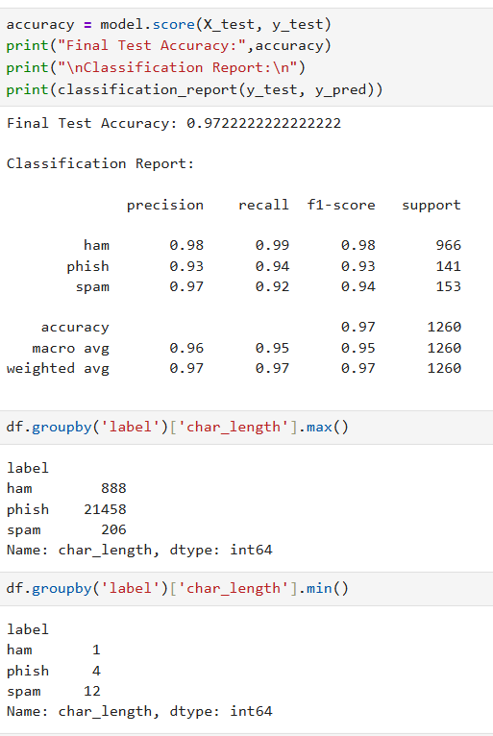
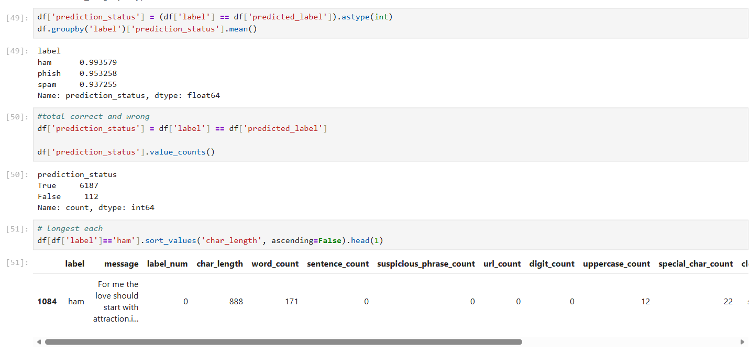
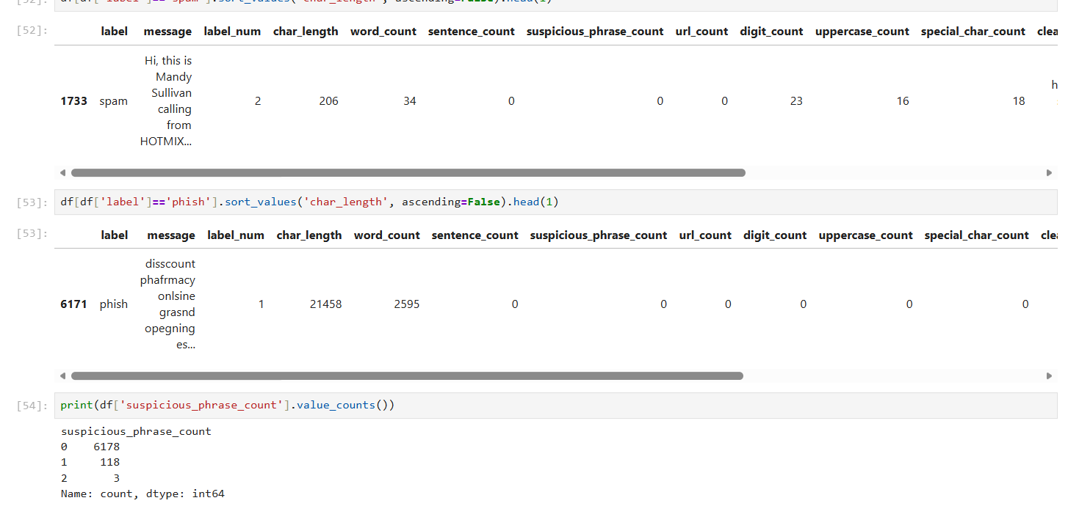
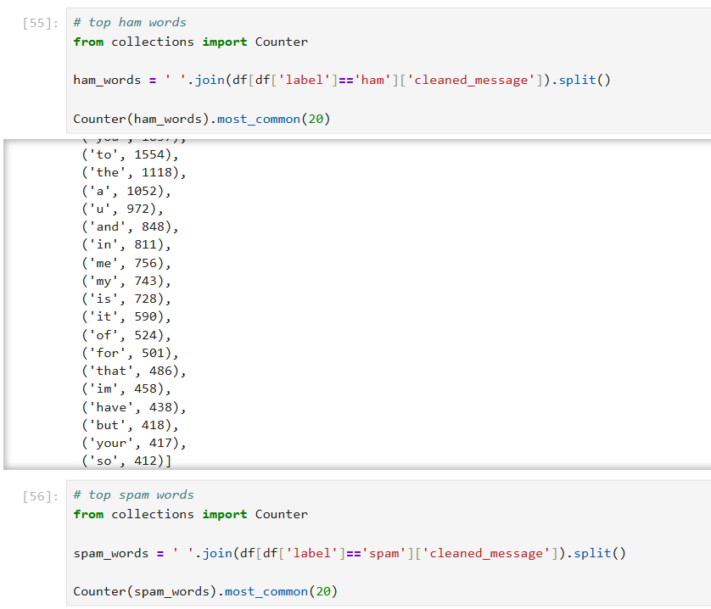
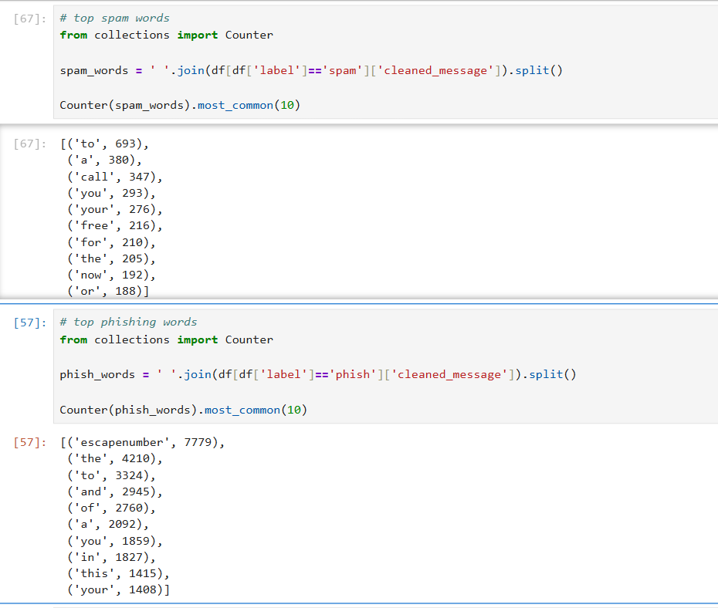
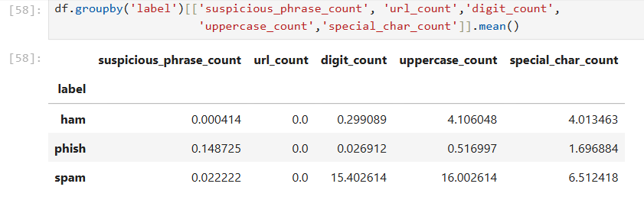
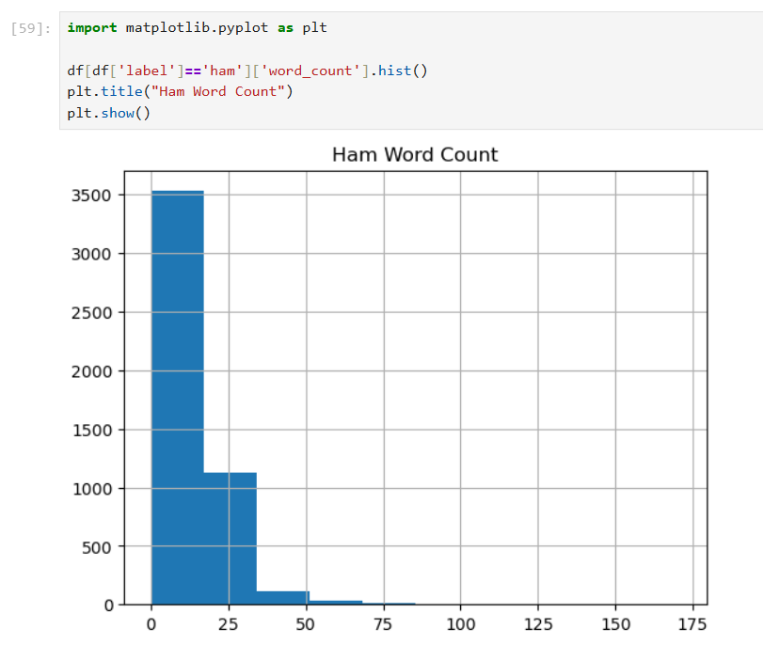
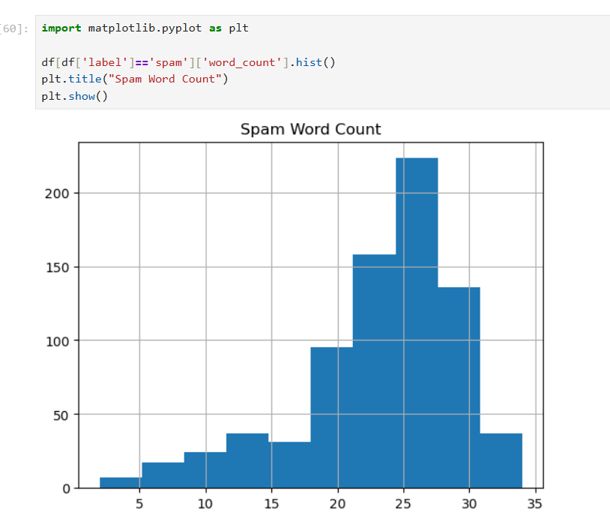
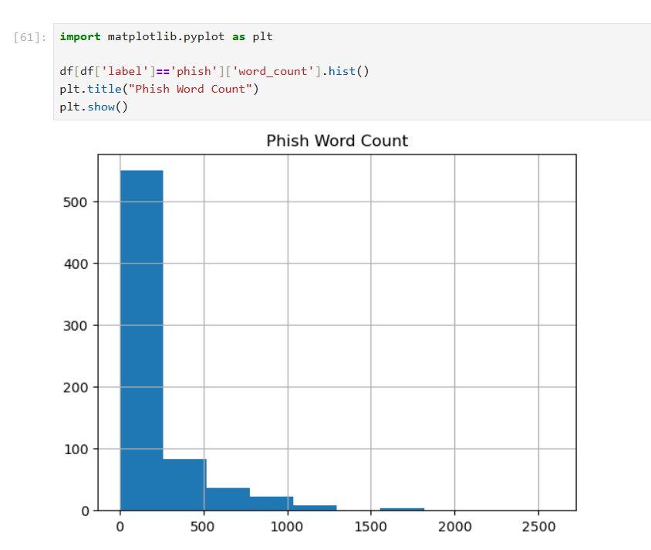
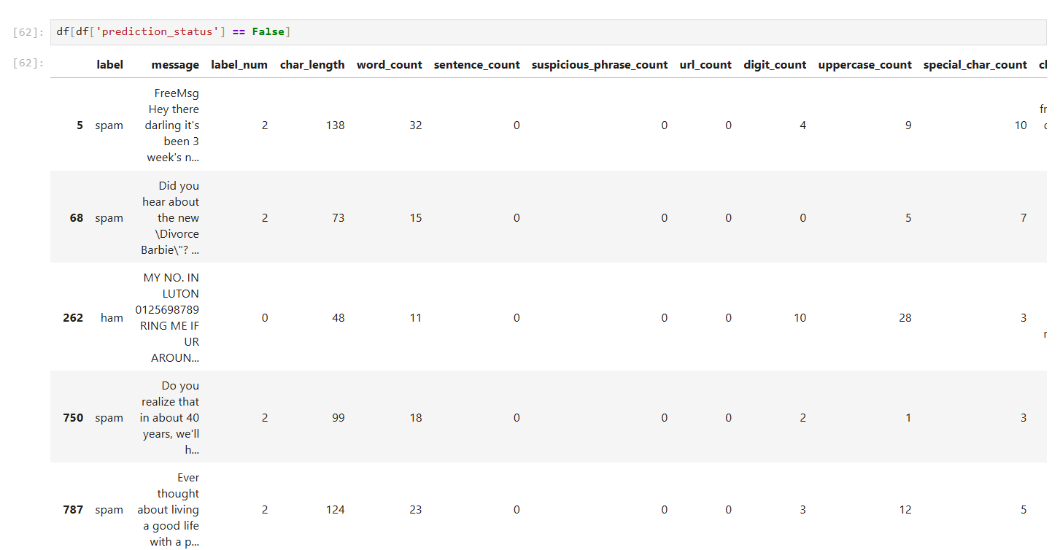
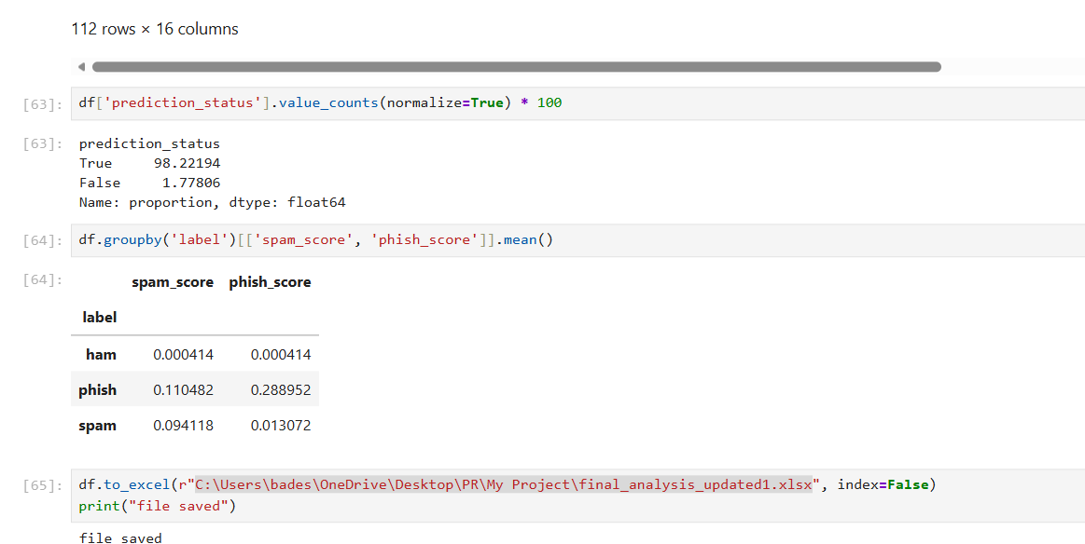
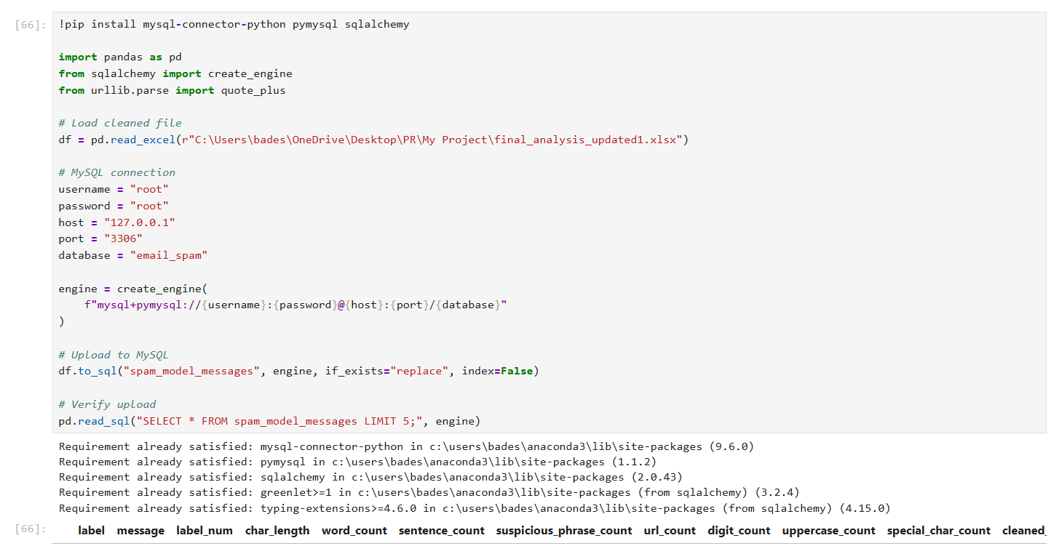
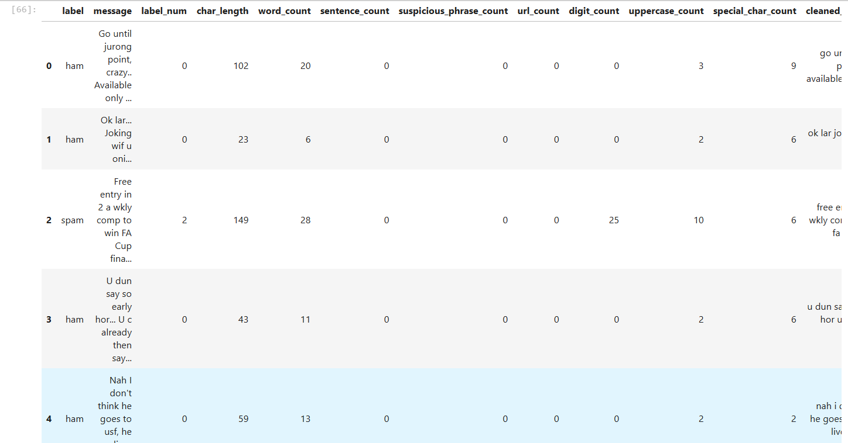

SQL OUTPUTS
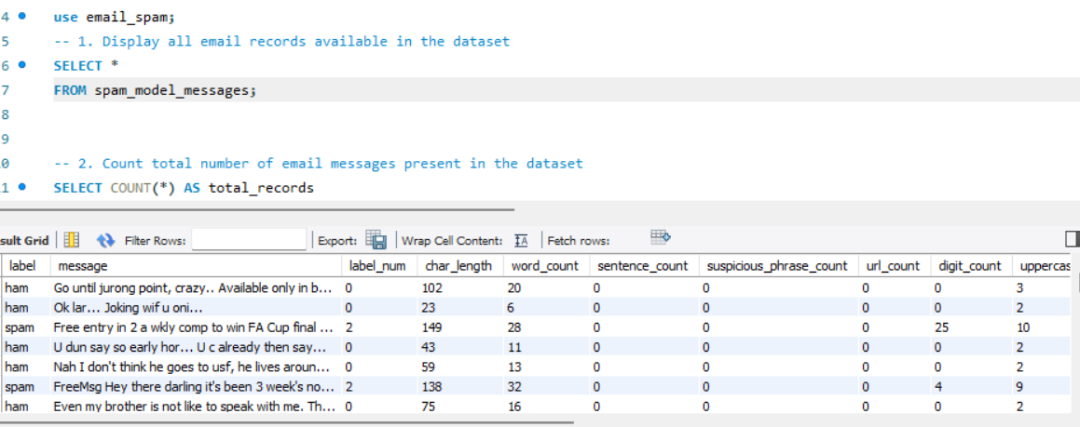
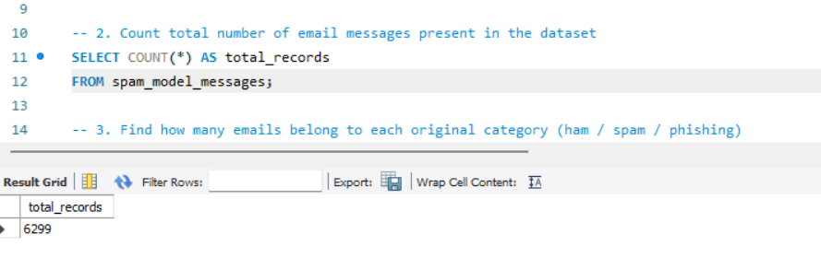
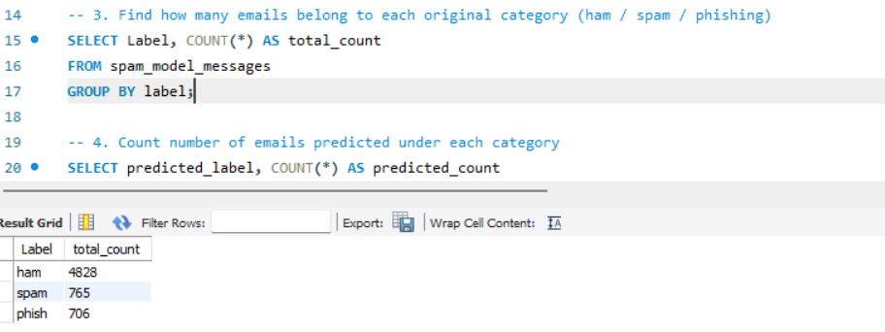
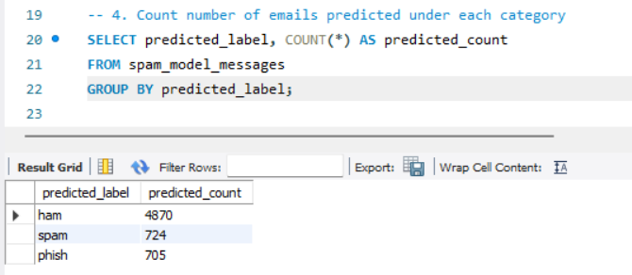
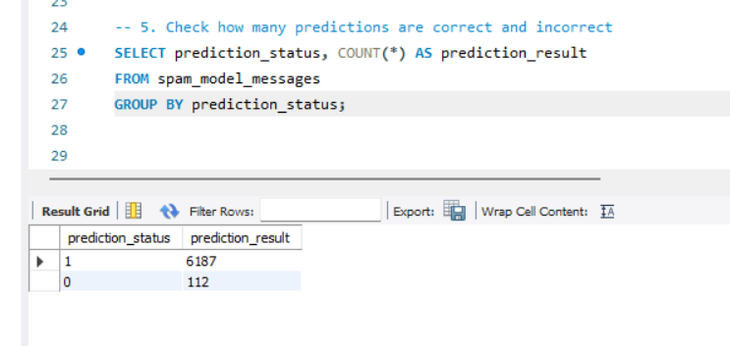
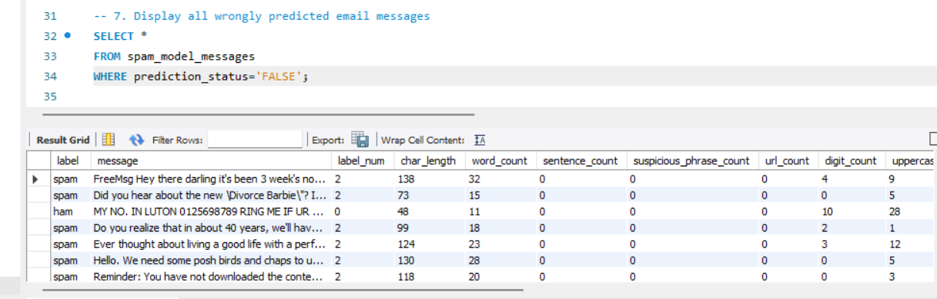
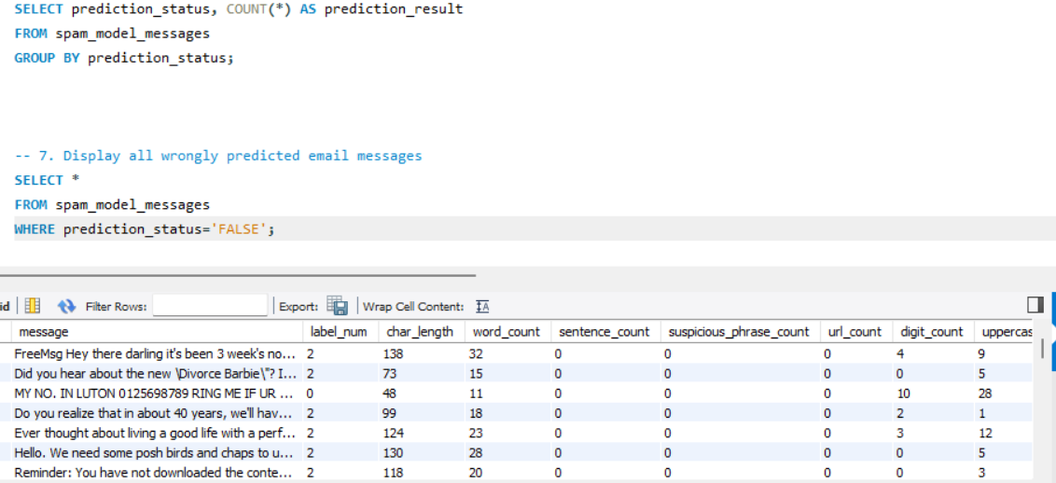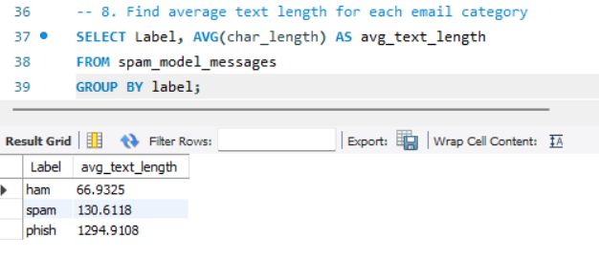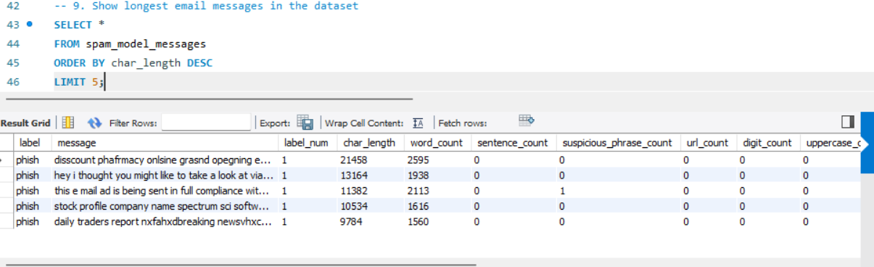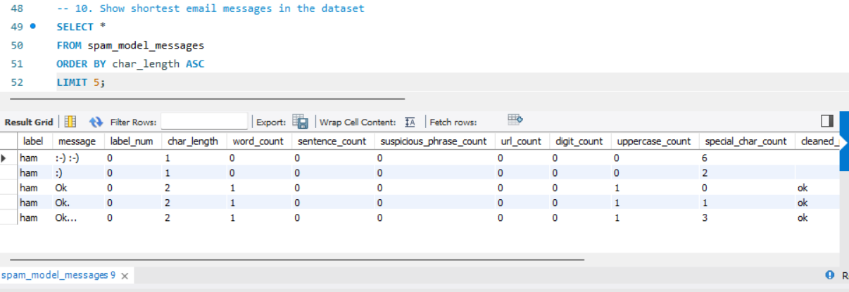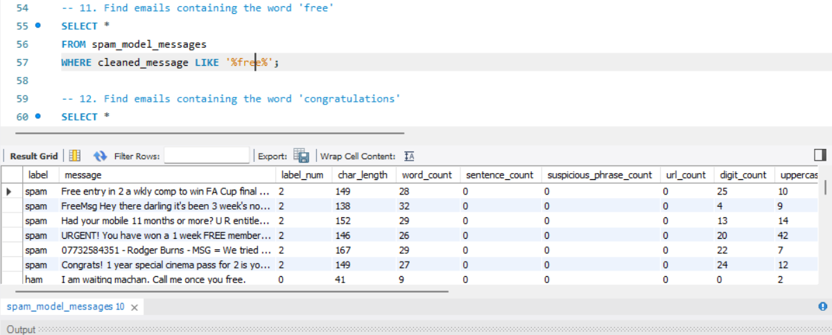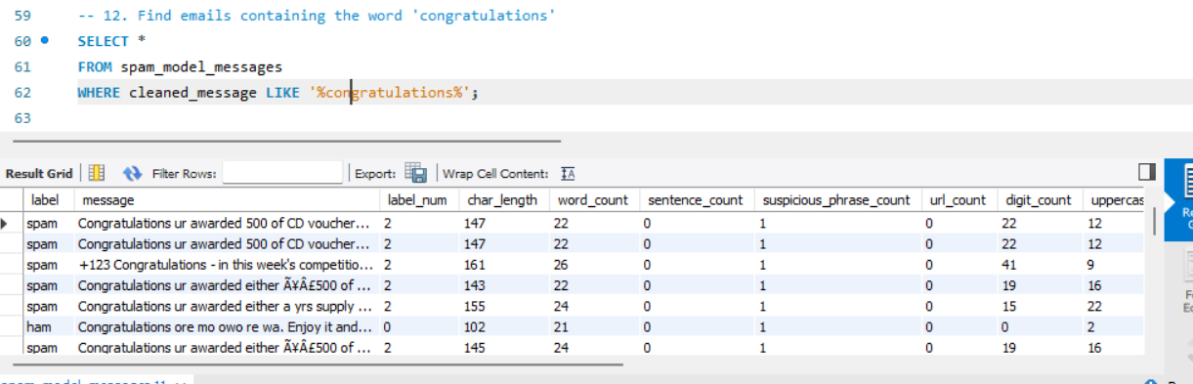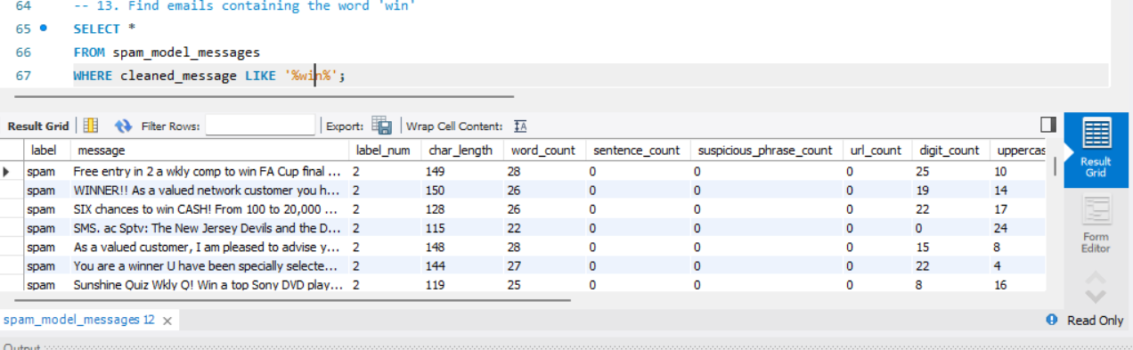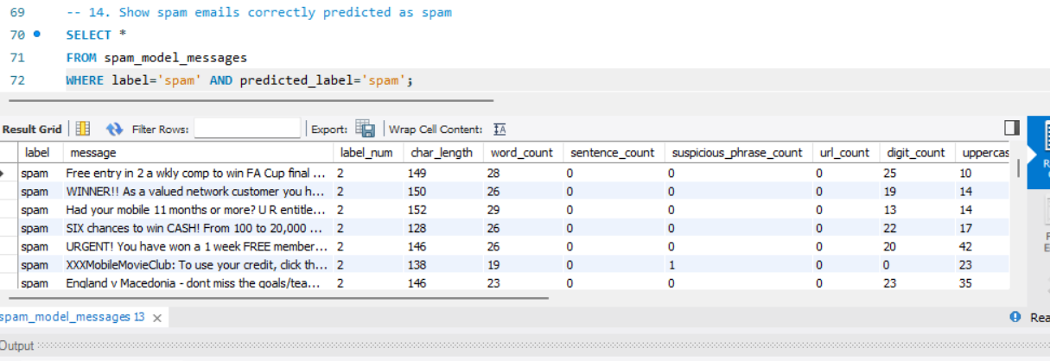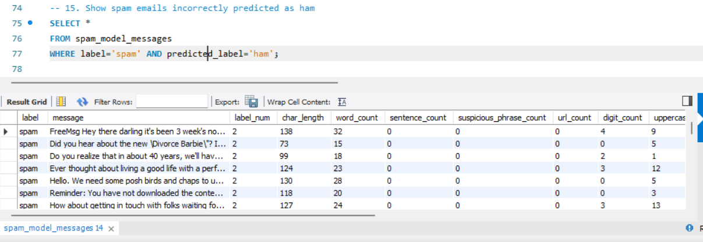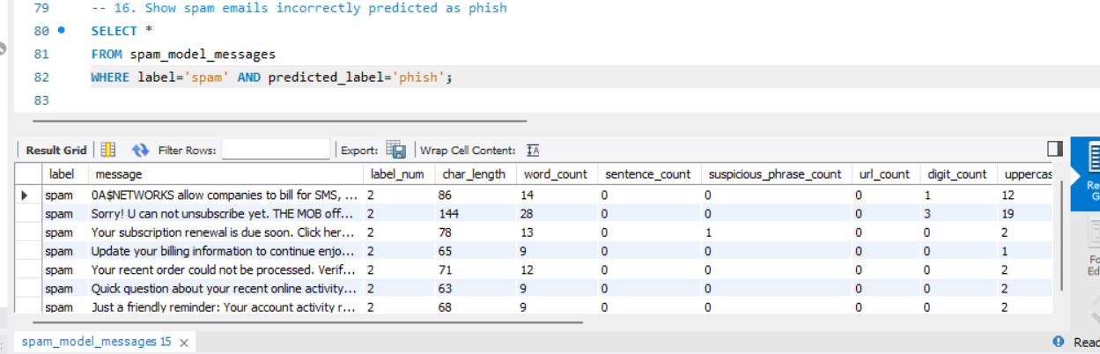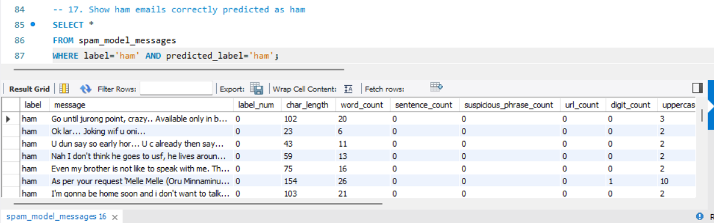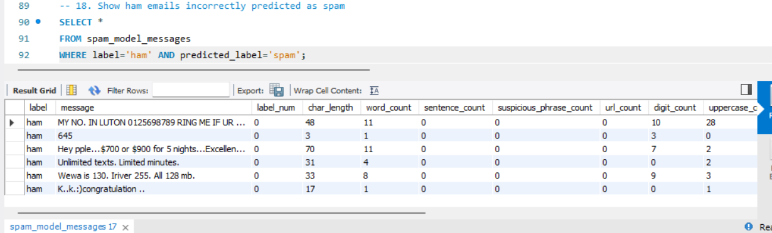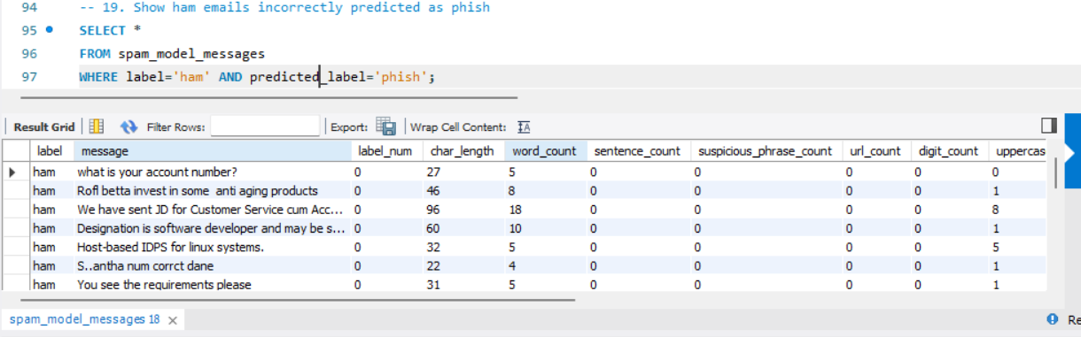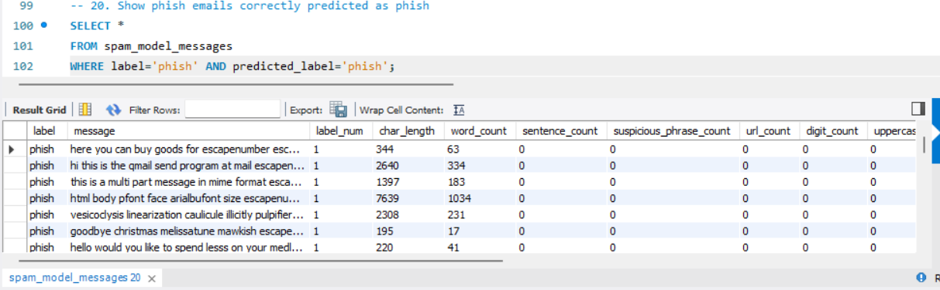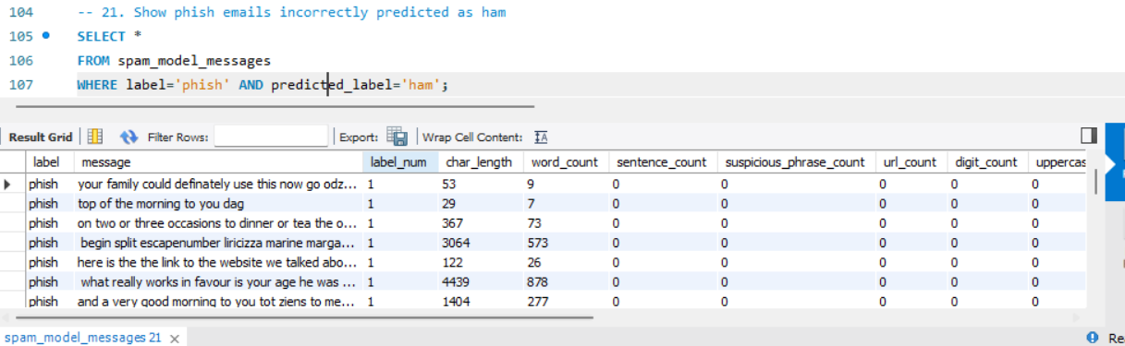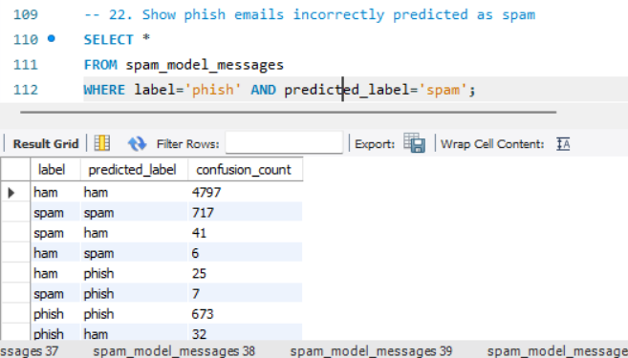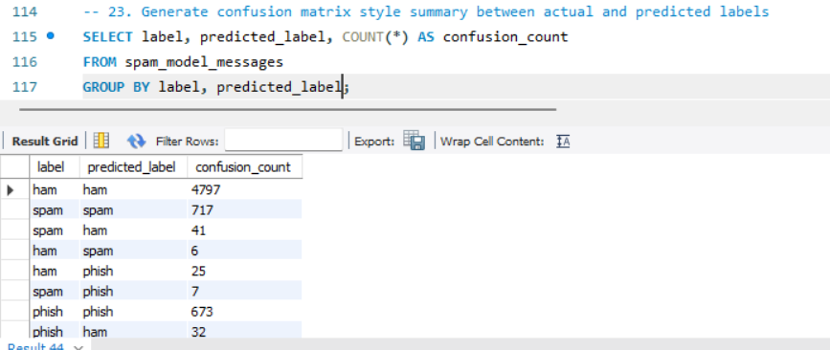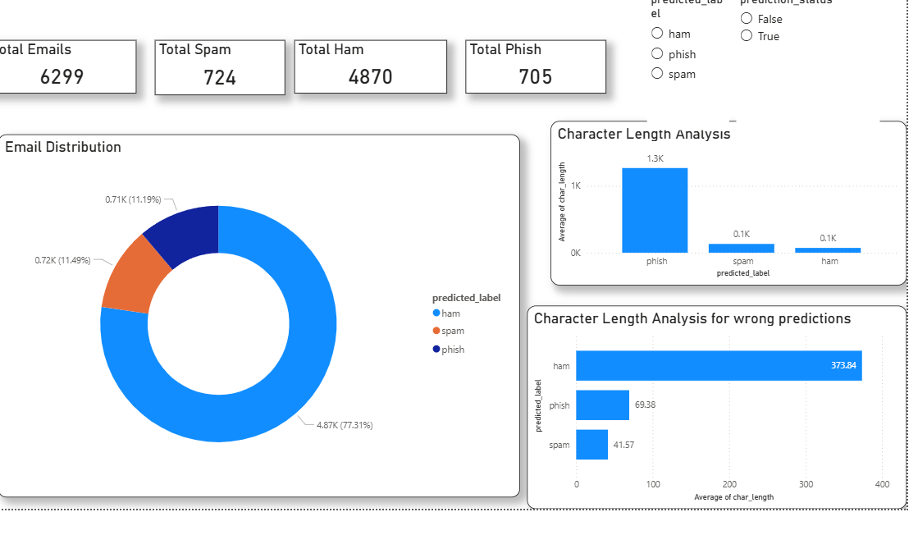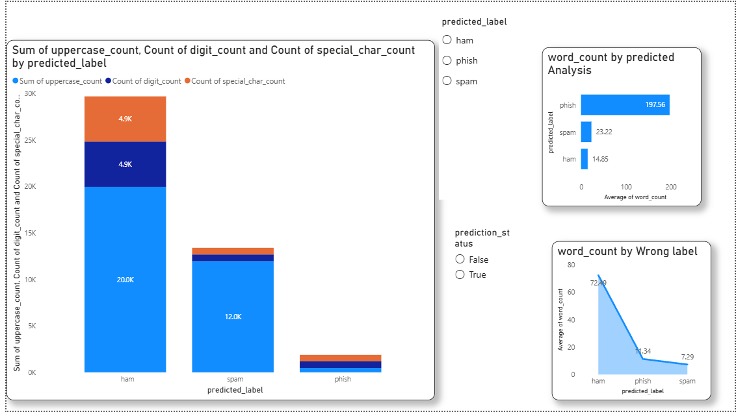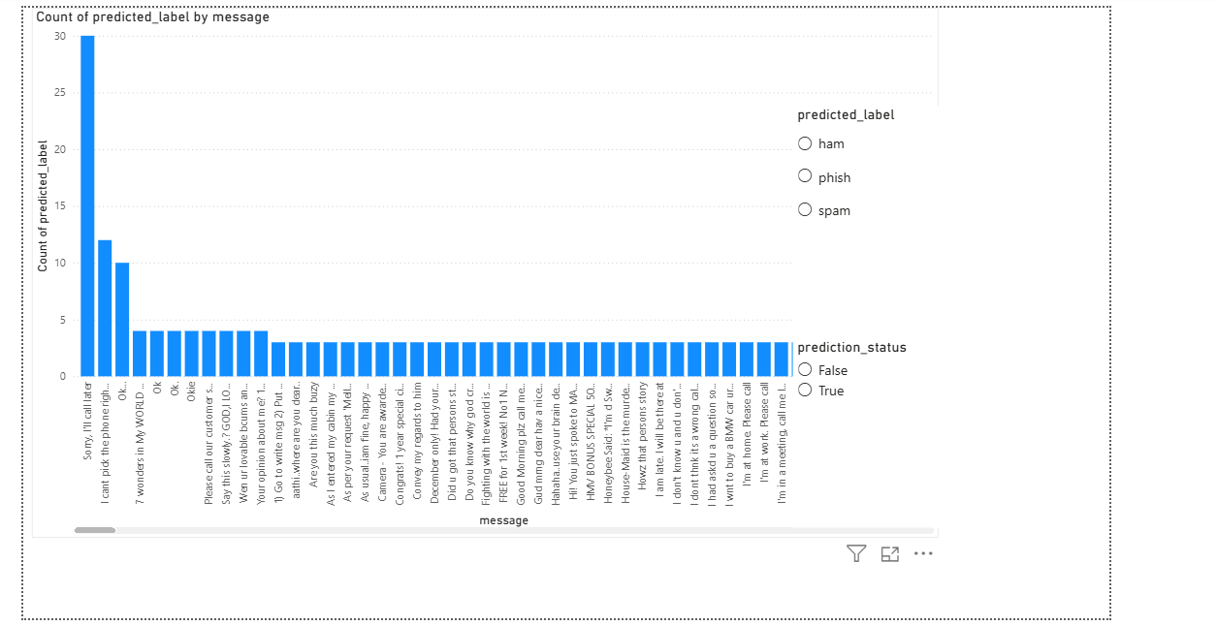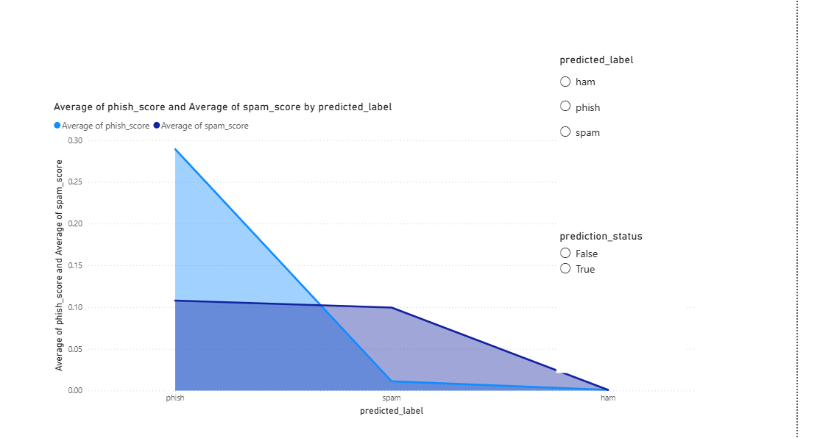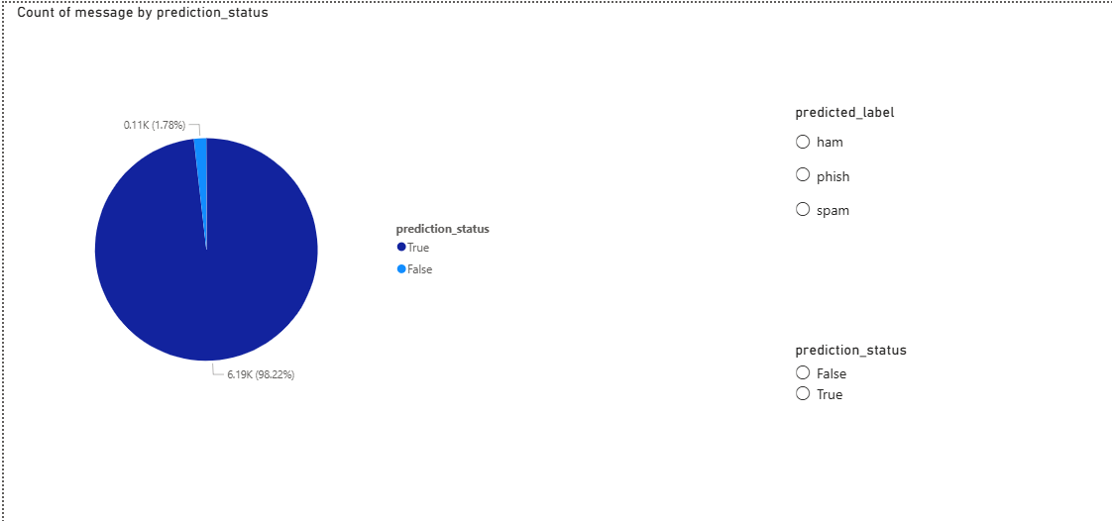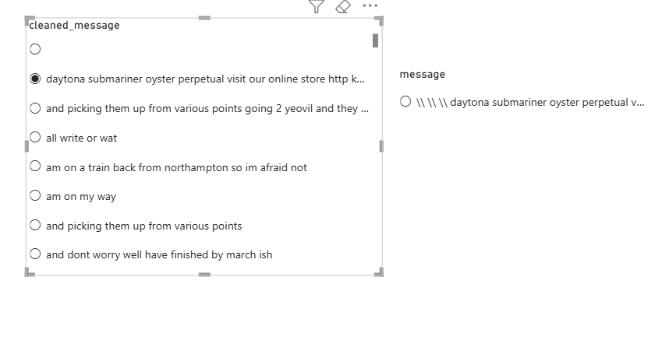

14. OUTPUT AND ANALYSIS
The outputs of the project represent the results obtained after performing data processing and analysis on the email dataset. These outputs mainly include structured query results, tables, and visual representations that highlight patterns in the data. The results provided in the document show how the dataset behaves when examined through different analytical perspectives.
The first set of outputs focuses on category distribution. The result shows the number of emails present in each category such as spam, ham, and phishing. From this output, a clear pattern can be observed in how the data is distributed. In most cases, spam messages appear in higher numbers compared to other categories, while ham messages represent regular communication. Phishing messages may appear less frequently but are distinct in nature. This distribution helps in understanding the overall composition of the dataset and highlights which type of messages are more dominant. The insight gained from this is that unwanted messages form a significant portion of email data, which makes analysis important for proper handling.
Another output presents message length analysis. This result shows how the length of email messages varies across different categories. A noticeable trend is that spam emails often have longer content with repeated phrases, while ham emails tend to have moderate and meaningful length. Phishing emails show variation but often include specific instructions or urgent messages. This pattern indicates that message length can act as an important factor in distinguishing between different types of emails. The insight here is that unusual message length, especially when combined with repetitive content, may indicate suspicious messages.
The next output highlights word frequency patterns. This analysis identifies commonly used words in each category of emails. The results show that spam messages frequently include promotional words and repeated terms, while phishing messages use words that create urgency or request sensitive actions. Ham messages, on the other hand, contain normal conversational words. This pattern clearly shows how language differs based on the purpose of the email. The insight gained is that word usage plays a key role in identifying the intent of a message, making it useful for understanding communication behavior.
Another important output focuses on structured query results that filter and group data based on specific conditions. These results show how data can be segmented to extract meaningful information. For example, grouping messages by category or filtering based on certain keywords reveals hidden patterns in the dataset. The trend observed here is that structured queries make it easier to isolate specific types of data and study them in detail. The insight is that organized querying improves the efficiency of analysis and helps in extracting targeted information from large datasets.
The visualization outputs further enhance the understanding of the data. Charts and graphs represent patterns such as category distribution, message length variation, and keyword frequency. These visual outputs make it easier to identify trends without manually examining large tables. For example, a bar chart showing category counts quickly highlights which type of email is most common, while a graph showing word frequency reveals dominant terms in each category. The insight from visualization is that graphical representation simplifies complex data and supports better interpretation.
Another observation from the outputs is the consistency of patterns across different analyses. Whether it is message length, word usage, or category distribution, similar trends are observed throughout the dataset. Spam messages consistently show repetitive and promotional characteristics, phishing messages show targeted and urgent language, and ham messages maintain a regular communication style. This consistency strengthens the reliability of the analysis and confirms that the patterns identified are meaningful.
Overall, the outputs provide a clear and detailed understanding of email data behavior. They show how different types of messages can be analyzed based on content, structure, and frequency of words. The patterns observed across various outputs help in distinguishing between normal and suspicious emails. These insights demonstrate the effectiveness of the analytical approach used in the project and highlight the importance of structured data analysis in understanding real world communication patterns.
15. OVERALL CONCLUSION
The project provides a comprehensive understanding of email data by analyzing different types of messages such as spam, ham, and phishing. Through a structured approach, the system successfully transforms raw email data into meaningful insights by applying data preprocessing, structured storage, analysis, and visualization techniques. The outputs generated during the analysis clearly highlight how different categories of emails vary in terms of content, structure, and communication style.
From the analysis, it is observed that spam messages are often characterized by repetitive content and promotional language, while phishing emails use targeted and urgent wording to influence user actions. In contrast, ham emails maintain a natural and consistent communication style. Patterns such as message length, word frequency, and category distribution play a significant role in distinguishing between these types of emails. These observations confirm that email data contains identifiable patterns that can be effectively analyzed using structured methods.
The project demonstrates the importance of proper data preprocessing in achieving accurate results. Cleaning and organizing the data ensures consistency and improves the reliability of analysis. The use of structured storage allows efficient handling of large datasets, while query based analysis helps in extracting meaningful information quickly. Visualization further enhances understanding by presenting complex data in a simple and clear format.
One of the key outcomes of the project is the ability to analyze large volumes of data efficiently without relying on manual processes. The system reduces time and effort by automating various steps in the workflow. It also ensures consistency in results, making the analysis more reliable. The ability to identify patterns and trends in email data adds value to the dataset and supports better understanding of communication behavior.
The project also highlights practical benefits in real world scenarios. The insights gained from the analysis can be used to improve email management, understand user communication patterns, and identify suspicious messages more effectively. By studying how different types of emails behave, the system contributes to improving overall efficiency and awareness in handling digital communication.
In terms of learning outcomes, the project provides hands on experience in handling real world datasets and applying structured data analysis techniques. It helps in understanding the complete workflow from data collection to final insight generation. The project also strengthens knowledge in data preprocessing, query based analysis, and visualization, which are essential skills in the field of data analytics.
Overall, the project successfully achieves its objective of analyzing email data and identifying meaningful patterns across different categories. It demonstrates how structured data handling and analysis can provide valuable insights and improve understanding of real world data. The results confirm that a systematic approach to data analytics can effectively transform raw information into useful knowledge.

